
founded 1782
300 Washington Avenue chestertown, maryland 21620-1197

Standard Operating Procedure No. 2
Blood Collection and Injection Sites and Volumes in Rodents

Blood sampling in rodents can be achieved in many ways. Techniques and guidelines vary depending on the species, and duration, frequency, and amount of blood sampling. Repeated blood sampling is limited to 1% of the body weight of the animal withdrawn once every two weeks. For example, a 20 gram mouse can have 200 µl of blood or a 200 gram rat can have 2 ml of blood withdrawn every two weeks. Larger quantities of blood may be withdrawn under anesthesia as a terminal procedure. Serial blood sampling can be accomplished in rodents safely by following these guidelines.

Mice - the following sites are suitable for repeated sampling and do not require anesthesia:
- Mandibular vein - use the Goldenrod lancets available in the necropsy room. Restrain the mouse by the scruff and place on lab bench. Using the lancet, puncture the skin behind and below the jaw. Collect the drop of blood using collection device. Apply pressure to puncture site and release mouse back into cage. Refer to the following website for more instructions: http://www.medipoint.com/html/directions_for_use1.html.
- Lateral saphenous vein - Restrain mouse in plastic conical tube with air holes. Shave the outside surface of the hind leg and clean with alcohol. Applying Vaseline to the skin surface will help prevent wicking of the blood. Place a tourniquet above the knee and pierce the saphenous vein with a 22 ga needle or scalpel blade and collect the drop of blood with the collection device. Apply pressure to stop bleeding and return mouse to cage. Pictures of this procedure are available on this website: http://www.uib.no/vivariet/mou_blood/Blood_coll_mice_.html.
- Lateral tail vein - Restrain mouse in plastic rodent restrainer. Warm tail under a light or by placing in warm water. Visualize the lateral tail vein and nick with needle (22 ga or smaller) or scalpel blade. Collect blood drop using collection device. Apply pressure to stop bleeding and return mouse to cage.
- Retro-orbital sinus - This procedure must only be done by a highly trained person. Restrain the mouse by the scruff and place on lab bench. Use the finger and thumb to stretch the skin over the eye area to retract skin and protrude eyeball. Insert a glass microcapillary tube in the medial canthus of the eye using a gentle twisting motion. Insert until blood enters the tube. Collect blood, remove tube and hold eye closed for a few seconds. Release mouse back into cage.

The following sites of collection must be used under anesthesia and as a terminal event. The mouse must be euthanized immediately following the procedure.

- Cardiac puncture - Under a deep plane of anesthesia, lay mouse on its back. Using a 22 ga or smaller needle attached to a 3 ml syringe, enter the chest cavity at the point where the xiphoid process intersects with the lowest rib directing the needle just left of the midline. Pull back on the syringe gently until blood enters the syringe. Alternatively the chest cavity can be opened and blood drawn directly from the heart. The mouse must be euthanized immediately following the procedure.
- Trunk blood collection - Under a deep plane of anesthesia, decapitate mouse using guillotine and collect blood in appropriate collection device.

Rats - Similar sites can be used for repeated sampling and do not require anesthesia in rats.

- Lateral saphenous vein - Restrain rat in plastic rodent restrainer. Shave the outside surface of the hind leg and clean with alcohol. Applying Vaseline to the skin surface will help prevent wicking of the blood. Place a tourniquet above the knee and pierce the saphenous vein with a 22 ga needle or scalpel blade and collect the drop of blood with the collection device. Apply pressure to stop bleeding and return rat to cage. Pictures of this procedure using mice are available on this website: http://www.uib.no/vivariet/mou_blood/Blood_coll_mice_.html.
- Lateral tail vein - Restrain rat in plastic rodent restrainer. Warm tail under a light or by placing in warm water. Visualize the lateral tail vein and nick with needle (22 ga or smaller) or scalpel blade. Collect blood drop using collection device. Apply pressure to stop bleeding and return rat to cage.

Blood may also be collected using the jugular vein in rats and this procedure must be done under anesthesia.

- Jugular vein - Anesthetize the rat following established SOP # 1. Place the rat on its back with the head extended facing the person collecting blood. Clip the hair lateral to the midline of the neck. Prep skin with either alcohol or Betadine™ solution. Use the angle of the jaw as a guideline and insert 21 ga needle with 3 ml syringe attached into the jugular vein at a 30º angle. Gently withdraw plunger to collect blood. Remove needle and apply pressure with a clean gauze pad to stop bleeding.

The following sites of collection must be used under anesthesia and as a terminal event. The rat must be euthanized immediately following the procedure.

- Cardiac puncture - Under a deep plane of anesthesia, lay rat on its back. Using a 20 ga or smaller needle attached to a 3 ml syringe, enter the chest cavity at the point where the xiphoid process intersects with the lowest rib directing the needle just left of the midline. Pull back on the syringe gently until blood enters the syringe. Alternatively the chest cavity can be opened and blood drawn directly from the heart. The rat must be euthanized immediately following the procedure.
- Trunk blood collection - Under a deep plane of anesthesia, decapitate rat using guillotine and collect blood in appropriate collection device.

Injection Routes
The volume of substance that can be injected into an animal will be dependent on the species, and weight/size of the animal. These tables give suggested maximum volumes that can be injected into rats and mice. These maximum volumes are meant to serve as guides for injection and must in no way be considered to be absolute values. Use your judgment and discretion whenever injecting substances into small animals and always try to use the smallest volume possible. See Table 1 for AAALAC recommended volumes.

Table 1. Administration volumes considered good practice (and possible maximal dose volumes)a

Species Route and volumes (ml kg−1)

Mouse | Oral  10 (50) | s.c.  10 (40) | i.p.  20 (80) | i.m.  0.05b | (0.1)b | i.v. (bolus)  5 | i.v. (slow inj.)  (25)
Rat | 10 (40) | 5 (10) | 10 (20) | 0.1b | (0.2)b | 5 | (20)
Rabbit | 10 (15) | 1 (2) | 5 (20) | 0.25 | (0.5) | 2 | (10)
Dog | 5 (15) | 1 (2) | 1 (20) | 0.25 | (0.5) | 2.5 | (5)
Macaque | 5 (15) | 2 (5) | c (10) | 0.25 | (0.5) | 2 | c
Marmoset | 10 (15) | 2 (5) | c (20) | 0.25 | (0.5) | 2.5 | (10)
Minipig | 10 (15) | 1 (2) | 1 (20) | 0.25 | (0.5) | 2.5 | (5)
aFor non-aqueous injectates, consideration must be given to time of absorption before re-dosing. No more than two intramuscular sites should be used per day. Subcutaneous sites should be limited to two or three sites per day. The subcutaneous site does not include Freund’s adjuvant administration.
bValues in millilitres per site.
cData not available.

Subcutaneous (s.c.)
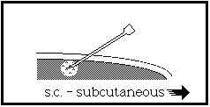

Intramuscular(i.m.)
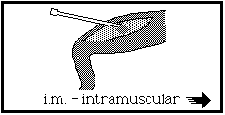
Intravenous(i.v.)
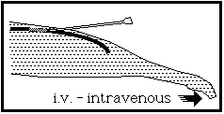
Intraperitoneal (i.p.)
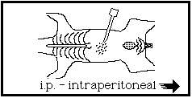
Remember when injecting intraperitoneally - Hold the animal with the head down
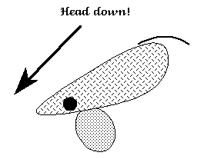
Don’t inject too deeply, make a "stopper"
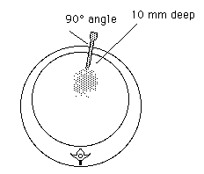 | 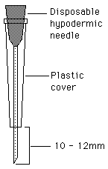
Remember the anatomic markers
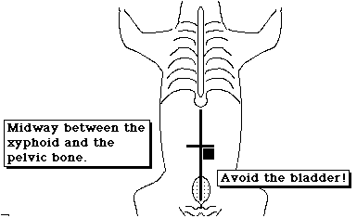

References:
Diehl, K, Hull, R, Morton D, Pfister, R, Rabemampianina, Y, Smith, D, Vidal, J and van de Vorstenbosch, C. A Good Practice Guide to the Administration of Substances and Removal of Blood, including Routes and Volumes. J. Appl. Toxicol. 2001; 21, 15-23.
http://www.aaalac.org/accreditation/RefResources/BloodRemoval.pdf

Turner, P, Brabb, T, Pekow, C and Vasbinder M. Administration of Substances to Laboratory Animals: Routes of Administration and Factors to Consider. J Am Assoc Lab Anim Sci . 2011;50:600-613.
http://www.ncbi.nlm.nih.gov/pmc/articles/PMC3189662/

Administration of Substances to Laboratory Animals: Equipment Considerations, Vehicle Selection, and solute Preparation. Journal of the American Association for Laboratory Animal Science. September 2011, Vol 50, No 5, 614–627

http://www.ncbi.nlm.nih.gov/pmc/articles/PMC3189663/

