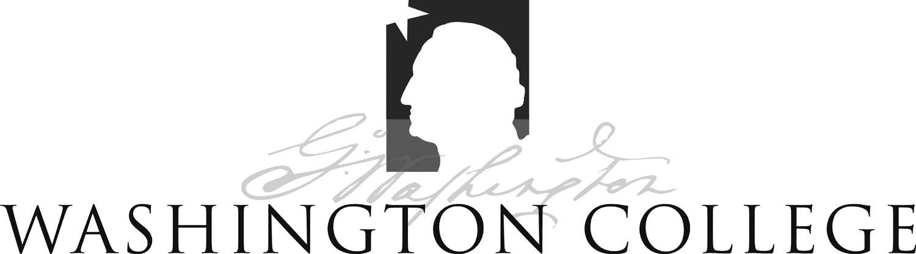
founded 1782
300 Washington Avenue chestertown, maryland 21620-1197

Standard Operating Procedure No. 6
Preparation of Sterile Non-Pharmaceutical Grade Compounds

OLAW (NIH) and USDA policy states that non-pharmaceutical grade compounds in research animals under certain circumstances has been, and will continue to be, a necessary and acceptable component of biomedical research. Their use should be based upon:
- Scientific necessity
- Non-availability of acceptable veterinary or human pharmaceutical-grade compounds
- Specific review and approval by the IACUC

No reagent-grade chemicals may be used in research animals if a pharmaceutical-grade compound is available through human or veterinary suppliers. Examples of available pharmaceutical-grade compounds frequently used in research animals include (but are not limited to): ketamine, xylazine, diazepam, buprenorphine, cefazolin, isoflurane and (sometimes) pentobarbital. Cost savings alone do not justify the use of non-pharmaceutical grade compounds in animals. Terminal procedures under anesthesia may be considered for exception to these guidelines with approval from the IACUC.

If a pharmaceutical-grade compound is not available through human or veterinary suppliers, the Principal Investigator or their staff may compound the drug in their laboratory. Examples of compounds not always available through suppliers include (but are not limited to): experimental test compounds and (sometimes) pentobarbital. If the drug is to be compounded the following procedures must be followed to insure sterility of the final product:
- All manipulations must occur in sterile vessels using sterile instruments (spatulas, syringes/needles, dosing vials, etc…). Work should be carried out in a biosafety cabinet or chemical fume hood to reduce contamination of the area.
- The drug must be reconstituted with sterile diluents (e.g., water, Phosphate Buffered Saline, DMSO, ethanol, oil) prepared by filtration through a 0.2 micron filter or by autoclaving according to the instructions provided by the manufacturer of the reagent-grade chemical.
- The final solution should be adjusted so that it has a pH value of between 4 and 9.5.
- After thorough mixing, the solution must be filtered into a sterile vial through a 0.2 micron filter to ensure removal of bacteria and other contaminants.
- The vial must be labeled with the drug name, concentration of the solution, the date of compounding and the expiration date (maximum of six months from the date of compounding).

- The solution must be handled in a manner to ensure continued sterility of the contents.
- The expiration date of the compounded solution is six months from the date of compounding at a maximum. Any solution remaining after six months must be discarded and not used in laboratory animals.
- Regardless of age, solutions should be discarded if changes in color and/or precipitation occur.

Special circumstances for the utilization of Pentobarbital

Pentobarbital is available through only one supplier (Nembutal® from Akorn Pharmaceuticals) at a cost of $1386.31 per 50 ml bottle (as of 6/18/12). Due to the exorbitant price, OLAW has allowed the use of reagent grade chemicals to prepare a comparable solution. See below excerpted from the OLAW webinar:

Use of Non-Pharmaceutical-Grade Chemicals and Other Substances in Research with Animals
Speakers: Patricia Brown, VMD, MS, DACLAM, OLAW, NIH, Carol Clarke, DVM, DACLAM, Animal Care, APHIS, USDA and Christian Newcomer, VMD, DACLAM, AAALAC International
Moderator: Jerry Collins, PhD, Division of Policy and Education, OLAW and Yale University.
Broadcast Date: March 1, 2012. A recording of the seminar can be viewed at http://grants.nih.gov/grants/olaw/2012-03-01_OLAW_Online_Seminar_Use_of_Non_Pharmaceutical_Grade%20Substances.wmv (Windows Media Player – 42 min).

24. Comment. I am writing to update OLAW on recent developments in the pentobarbital problem. Currently there is only one company producing Nembutal. This is licensed for human use but the distributor will sell it for animal use. Their current price is $1113 per 50 ml bottle. Not too many years ago, the cost was less than $50, then it increased to $300, then to $800 just a few months ago, now over $1000. The cost may continue to escalate as the company that acquired rights to manufacture it has a monopoly. Over the last year as prices increased and availability declined, researchers who were able converted to alternative anesthetics. A number of researchers are simply unable to switch due to scientific reasons. For them to pay these extreme prices would be a significant financial burden that may impact their research objectives.

Response. Regulatory guidance on this matter specifically allows for use of non-pharmaceutical-grade compounds due to non-availability and with IACUC approval. The exorbitant cost of this product has placed it logistically into the unavailable category. Pentobarbital from a reagent or analytical-grade powder, properly prepared by your pharmacist or other knowledgeable individual (e.g., chemist, veterinarian, researcher), with assurance of appropriate storage and handling, and approval by the IACUC is acceptable. IACUC approval can be institution-wide for the drug prepared in this fashion for all approved users."

The following is the formulation of the commercially available pentobarbital solution:

NEMBUTAL Sodium Solution (pentobarbital sodium injection, USP) is available in the following sizes:
20-mL multiple-dose vial, 1 g per vial (NDC 67386-501-52); and 50-mL multiple-dose vial, 2.5 g per vial (NDC 67386-501-55).
Each mL contains:
Pentobarbital Sodium, derivative of barbituric acid.......................................50 mg
Propylene glycol........................................................................................ 40% v/v
Alcohol............................................................................................................ 10%
Water for Injection.............................................................................................. qs
(pH adjusted to approximately 9.5 with hydrochloric acid and/or sodium hydroxide.)

The following is a scaled down formulation for the typical concentration and volume used in the vivarium based on the above formula:
To make 20 ml of a 48 mg/kg Pentobarbital solution:

0.96 g of sodium pentobarbital (Sigma P3761)
2 ml ethanol
8 ml propylene glycol
qs sterile water to 20 ml

adjust pH to between 4 and 9.5 with hydrochloric acid and/or sodium hydroxide

Special circumstances regarding the use of DMSO as a solvent:

Use as little as possible DMSO when dissolving drugs, preferably ≤ 5-10% w/v. Use of greater amounts has resulted in unanticipated consequences including death.

References:

Administration of Substances to Laboratory Animals: Equipment Considerations, Vehicle Selection, and solute Preparation. Journal of the American Association for Laboratory Animal Science. September 2011, Vol 50, No 5, 614–627

http://www.ncbi.nlm.nih.gov/pmc/articles/PMC3189663/

http://grants.nih.gov/grants/olaw/2012-03-01_OLAW_Online_Seminar_Use_of_Non_Pharmaceutical_Grade%20Substances.wmv

